CODE:-
import cv2
import numpy as np
from matplotlib import pyplot as plt

# Step 1: Paths of uploaded images (all 5)
image_paths = ["/content/ex1_1.png", "/content/ex1_2.png", "/content/ex1_3.png", "/content/ex1_4.png", "/content/ex1_5.png"]

# Step 2: Function for histogram equalization def histogram_equalization(image):
return cv2.equalizeHist(image)

# Step 3: Function for histogram matching def histogram_matching(source, reference):

# Compute histograms (normalized)

src_hist = cv2.calcHist([source], [0], None, [256], [0, 256])
ref_hist = cv2.calcHist([reference], [0], None, [256], [0, 256]) src_hist /= src_hist.sum()
ref_hist /= ref_hist.sum()

# Compute cumulative distribution functions (CDFs)

src_cdf = src_hist.cumsum() ref_cdf = ref_hist.cumsum()

# Mapping from source to reference
mapping = np.interp(src_cdf, ref_cdf, np.arange(256)) matched = mapping[source].astype(np.uint8)
return matched

# Step 4: Use first image as reference
ref_img = cv2.imread(image_paths[0], cv2.IMREAD_GRAYSCALE)

# Step 5: Process each image
for i, path in enumerate(image_paths): # Load as grayscale

img = cv2.imread(path, cv2.IMREAD_GRAYSCALE) if img is None:
print(f" Could not load image {path}") continue

# Histogram Equalization
eq_img = histogram_equalization(img)

# Histogram Matching with reference image matched_img = histogram_matching(img, ref_img)

# Show results plt.figure(figsize=(12, 6))

plt.subplot(1, 3, 1) plt.title(f'Original {i+1}') plt.imshow(img, cmap='gray') plt.axis('off')

plt.subplot(1, 3, 2) plt.title(f'Equalized {i+1}') plt.imshow(eq_img, cmap='gray') plt.axis('off')

plt.subplot(1, 3, 3) plt.title(f'Matched {i+1}')

plt.imshow(matched_img, cmap='gray') plt.axis('off')

plt.tight_layout() plt.show()

# Step 6: Observations print("\n Observations:")
print("1. Histogram Equalization improves overall contrast by redistributing intensity values.")
print("2. Histogram Matching modifies the input so it looks more like the reference image.")
print("3. Equalization is good for general enhancement, while Matching is useful when you want two images to have a similar tone distribution.")

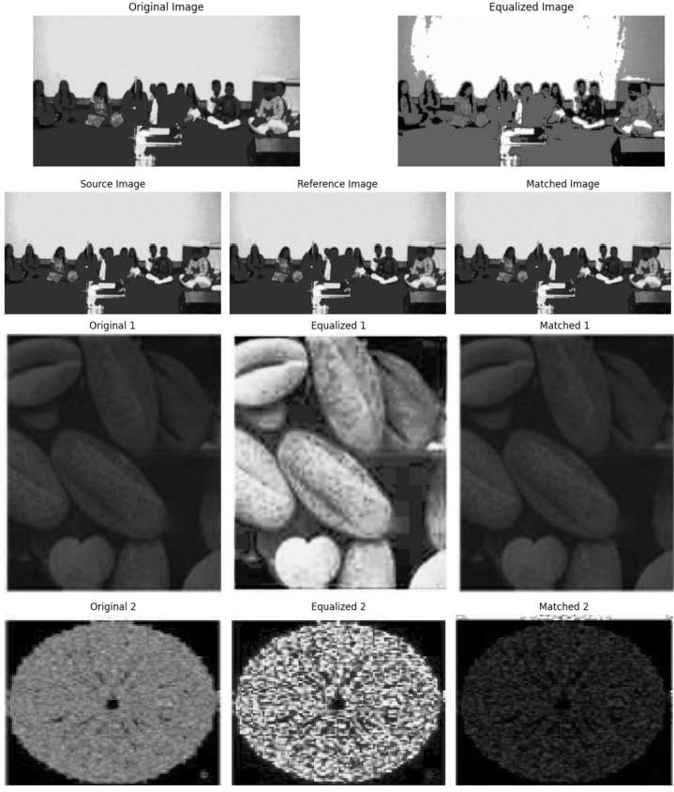
OUTPUT:-

OBSERVATION:-
• Histogram equalization improves image contrast by spreading intensity values, making dark regions clearer and bright regions stand out more.
• This technique enhances overall visibility, but sometimes the image looks “over-sharpened” because the contrast is stretched globally.
• In certain cases, equalized images may appear unnatural as the method does not adapt to the specific lighting style of the image.
• Histogram matching adjusts the tones of the source image so its brightness and contrast resemble that of a reference image.
• This produces more balanced and natural-looking results, as the output aligns with the reference image’s lighting and style.

CONCUSTION:-
We learn that histogram equalization is very effective when we want to enhance visibility and improve overall contrast in an image, but it may not always keep the natural appearance. On the other hand, histogram matching is more controlled, as it adapts the image brightness and contrast to a reference image, giving results that look more natural and consistent.

